Table of Contents
ABSTRACT 2
INTRODUCTION 2
SYSTEM ANALYSIS 3
SYSTEM DESIGN 3
FLOWCHART DESIGN: 3
ER DIAGRAM 4
WORK BREAKDOWN STRUCTURE (WBS) 5
GANTT CHART 5
Screenshots of the system 6
DATABASE DESIGN: 8
IMPLEMENTATION 9
TESTING & RESULTS 10
CONCLUSION & RECOMMENDATIONS 10
REFERENCES 11

ABSTRACT
This project presents a Digital Clinic Appointment and Medical Records System developed using PHP, MySQL, and Apache server. The system is designed to replace manual clinic record management with a computerized solution that improves efficiency, accuracy, and accessibility of patient data.
The system supports patient management, appointment scheduling, and medical record handling including diagnosis, treatment, and prescription storage. It ensures fast data retrieval, reduces redundancy, and improves healthcare service delivery.
The system was tested successfully and demonstrated full functionality in CRUD operations (Create, Read, Update, Delete).

INTRODUCTION
Healthcare institutions often rely on manual systems that are inefficient and error-prone. Digital transformation is necessary to improve service delivery.
Problem Statement:
Manual clinic systems suffer from:
- Data loss
- Slow retrieval of records
- Poor appointment tracking
- Human errors
Aim:
To design a web-based clinic management system that automates patient and medical record handling.
Objectives:
- Manage patient records efficiently
- Automate appointment scheduling
- Store medical records securely
- Improve data accessibility

SYSTEM ANALYSIS

Users of the System
- Admin
- Doctor
- Receptionist (optional future role)
Functional Requirements
- Patient registration
- Appointment booking
- Medical record entry
- Search functionality
- Update and delete operations
Non-Functional Requirements
- Fast response time
- Secure data handling
- User-friendly interface
- Reliable database system

SYSTEM DESIGN

Architecture
The system follows a 3-tier architecture:
- Presentation Layer (HTML/CSS)
- Application Layer (PHP)
- Database Layer (MySQL)

FLOWCHART DESIGN:
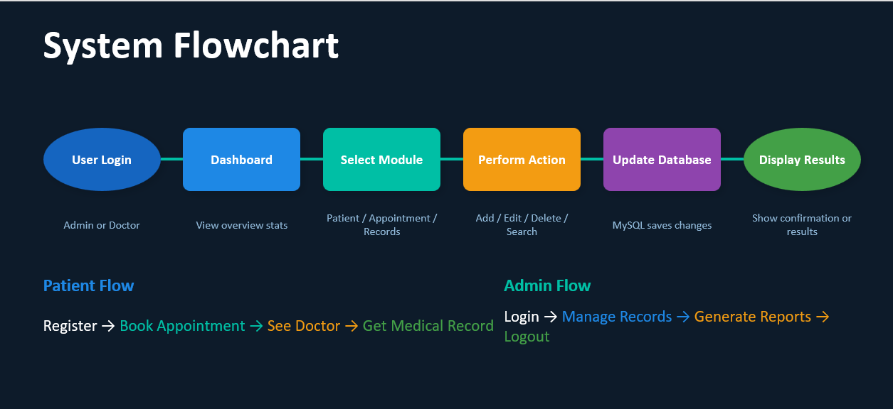

ER DIAGRAM

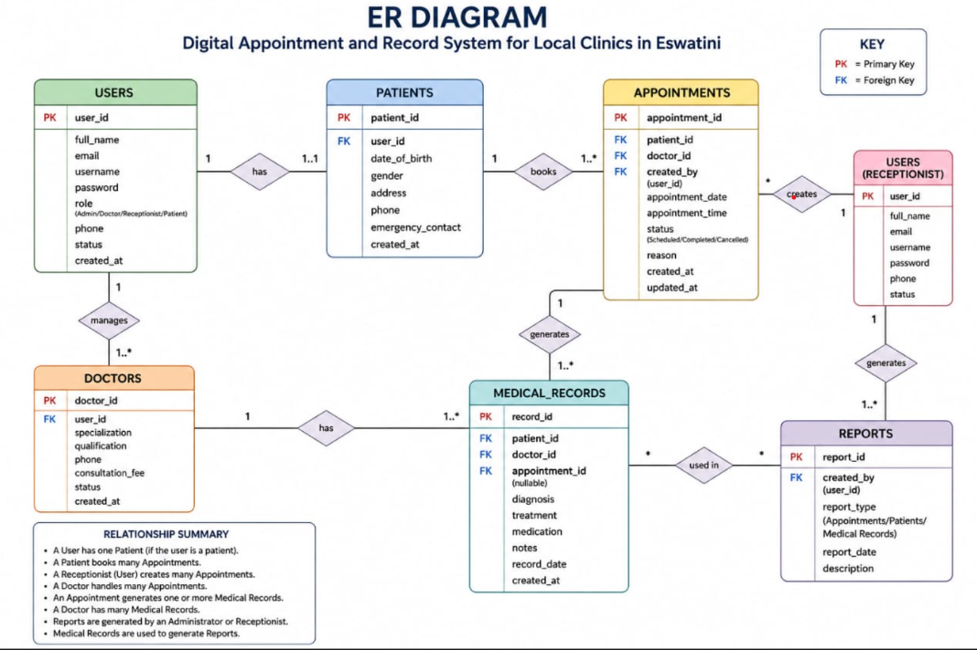

WORK BREAKDOWN STRUCTURE (WBS)

WBS | MAIN TASK | SUB-TASK | DELIVERABLE
1.0 | Project planning | Requirement Gathering | Project Requirements
1.1 | Project planning | Problem identification | Problem statement
2.0 | System design | Flowchart design | Flowchart
2.1 | System design | Database design | Database Tables
3.0 | System development | Patient module | Patient Management system
3.1 | System development | Appointment module | Appointment Management
3.2 | Testing | Medical Records module | Medical Record Management
4.0 | Testing | Unit writing | Error-Free system
4.1 | Documentation | Screenshots and results | Functional system
5.0 | Documentation |  | Final Documentation
5.1 |  |  | Project Report

GANTT CHART
Activities | Week 1 | Week 2 | Week 3 | Week 4 | Week 5 | Week 6
Requirement Gathering
Problem identification
Flowchart Design
Database Design
Patient module Development
Appointment module Development
Medical Records module
System Testing
Debugging and Error correction
Documentation writing

Gantt chart in Excel:
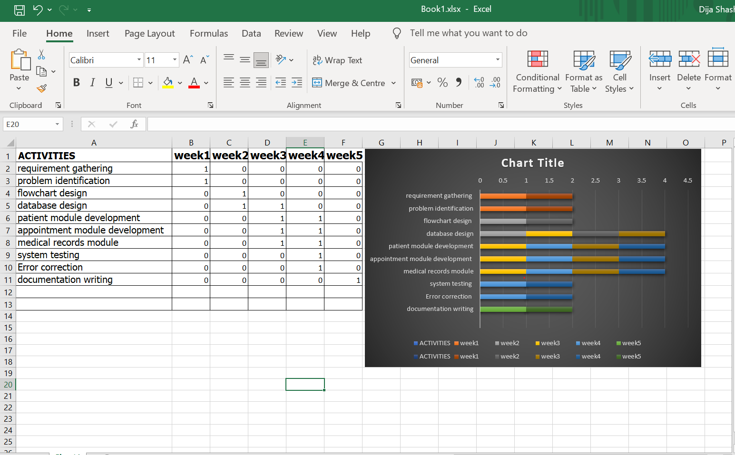
GITHUB
GitHub Repository Management
GitHub was used in this project as a version control and repository management platform. It provided a centralized location for storing and managing the source code of the Smart Clinic Management System. Through GitHub, all project files, including PHP scripts, database-related files, and documentation, were uploaded and maintained securely.
The repository also contains a README file that describes the purpose, features, and technologies used in the project. The use of GitHub facilitated file backup, project organization, and easy access to the source code. It also ensured that modifications made during the development process were properly managed and documented.
The following figures illustrate the GitHub repository containing the project files and the README documentation associated with the Smart Clinic Management System.

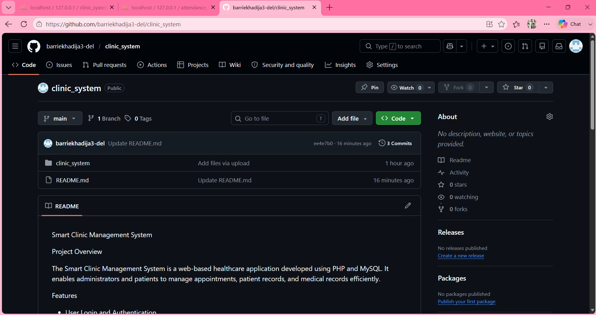

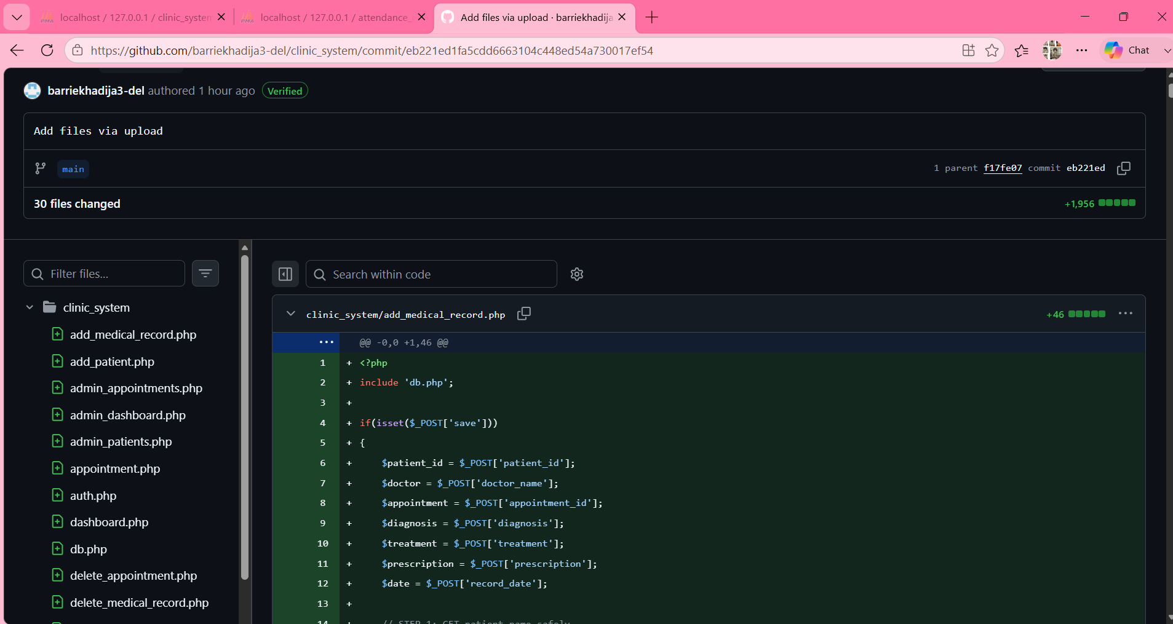

Screenshots of the system
- Login page
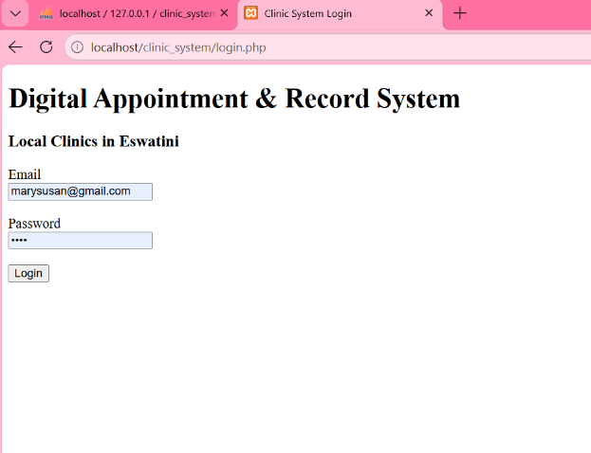
- Admin Dashboard
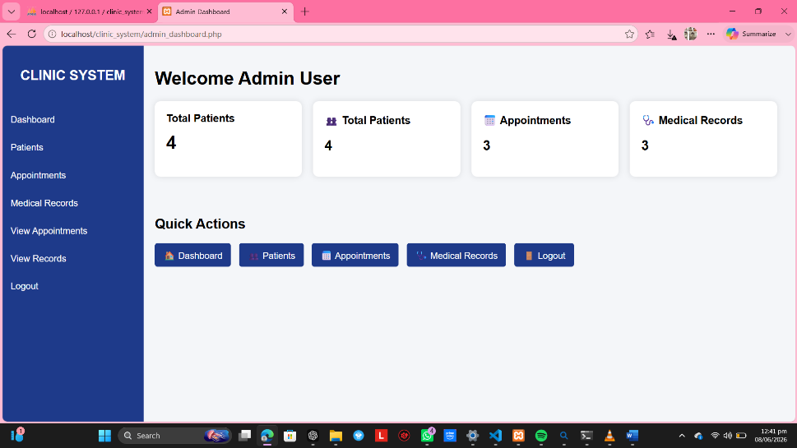
- Patient Dashboard
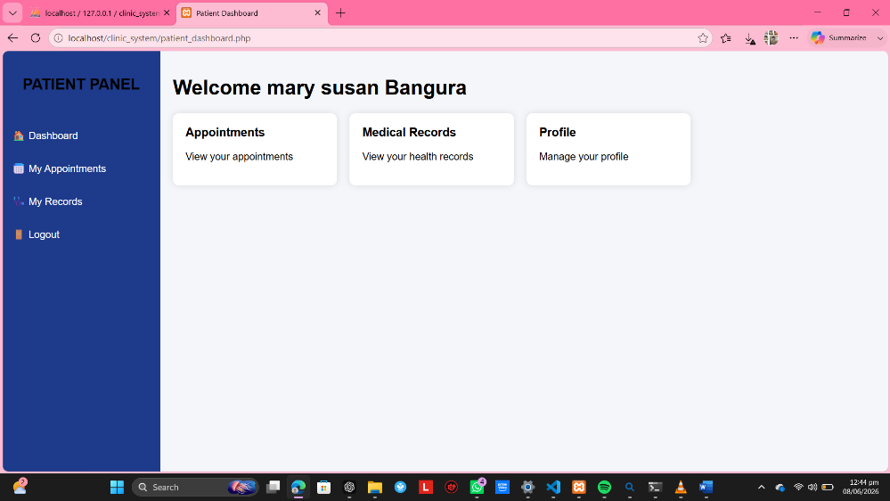

- Dr. Dashboard
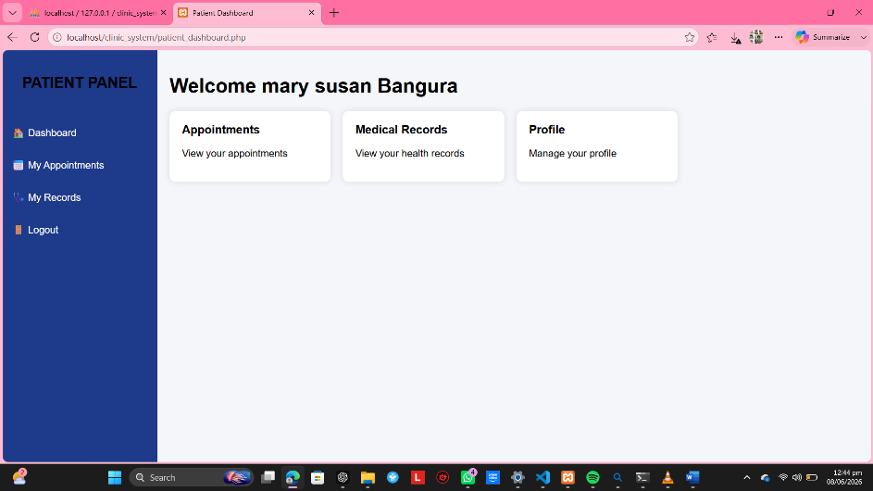
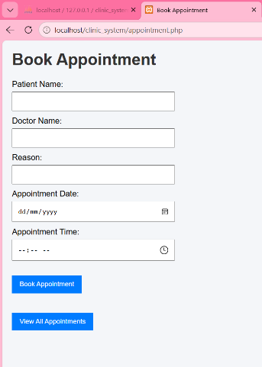
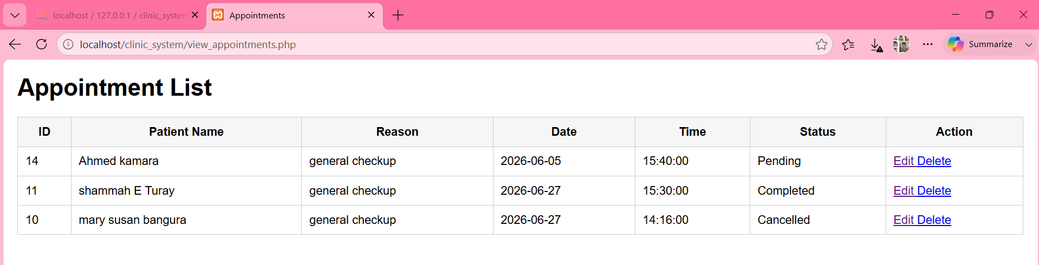
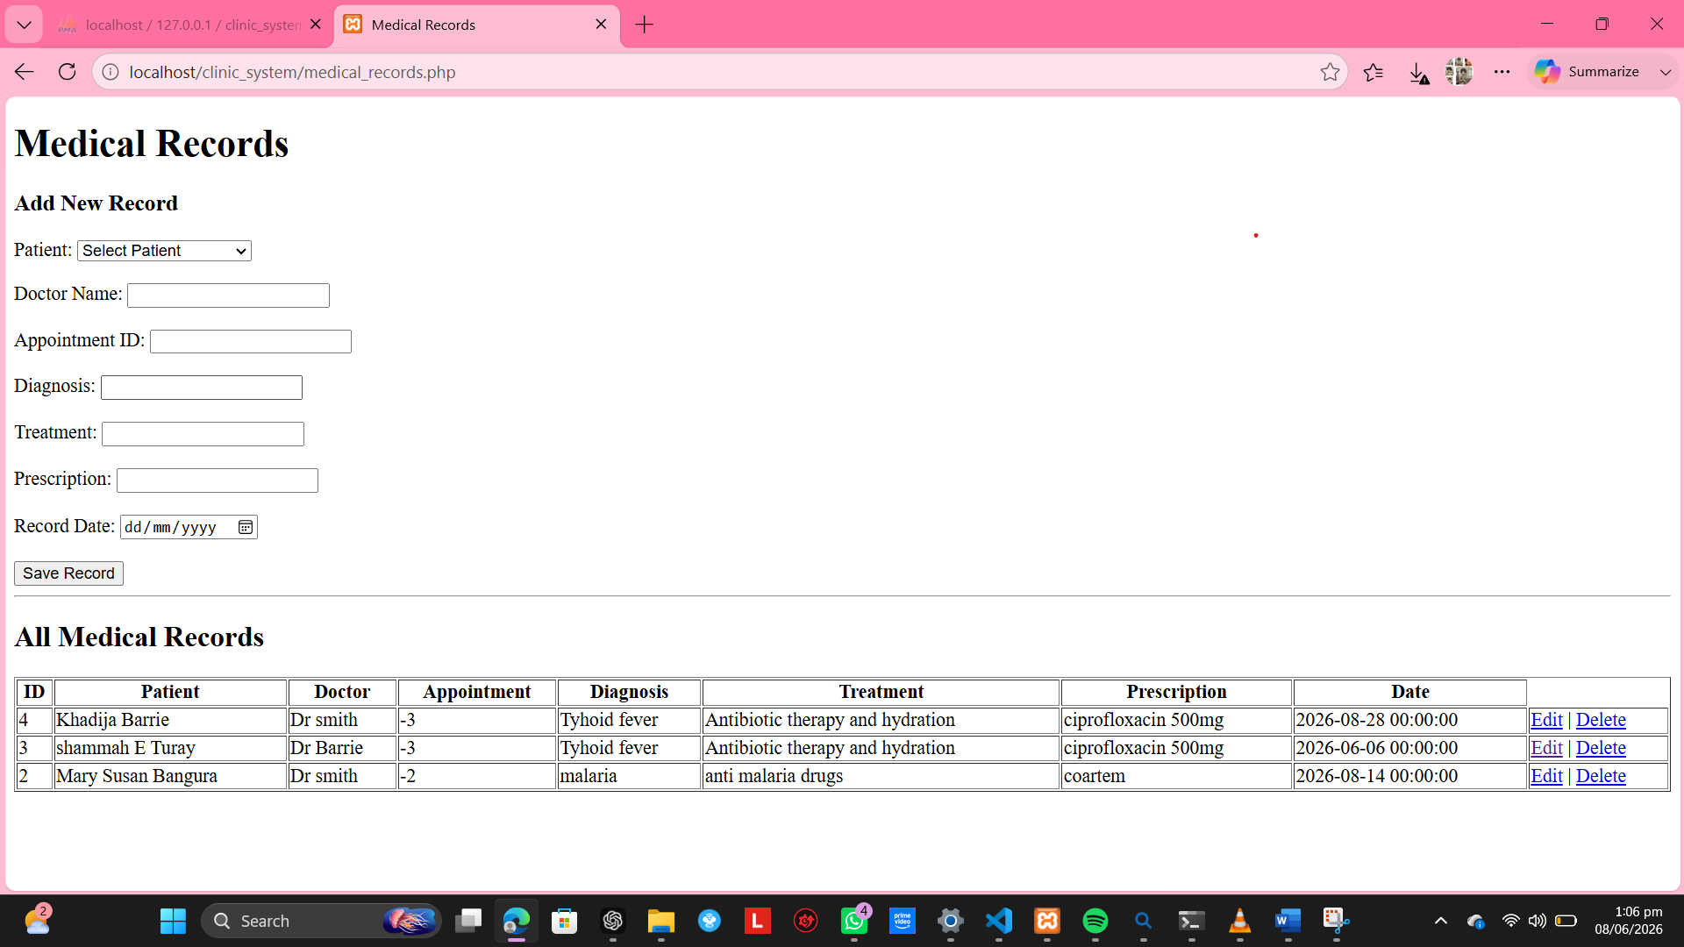

DATABASE DESIGN:

PATIENTS
Patient_id
Full_name
Gender
Phone
Address
Date_of_birth
MEDICAL_RECORDS
Record_id
Patient_name
Doctor_name
Appointment_id
Diagnosis
Treatment
prescription
Record_date
APPOINTMENTS
Appointment_id
Patient_id
Date
Time
Status

IMPLEMENTATION
- Technologies Used
- PHP (Backend logic)
- MySQL (Database)
- Apache (Server)
- HTML/CSS (Frontend)
- XAMPP (Development environment)

Modules Implemented
- Patient Module
- Add patient
- Edit patient
- Delete patient
- Search patient
Appointment Module
- Book appointment
- Update status
- View appointments
Medical Records Module
- Add diagnosis
- Add prescription
- View records

TESTING & RESULTS
Testing Types
- Unit testing
- Functional testing
- Database testing
Test Results
All modules function correctly:
- CRUD operations successful
- Search system working
- Data stored properly

CONCLUSION & RECOMMENDATIONS
CONCLUSION
The project successfully developed a functional clinic management system using PHP and MySQL.

Recommendations
- Add SMS notifications
- Add email alerts
- Improve UI/UX design
- Add role-based access control

REFERENCES
PHP Official Documentation
MySQL Manual
W3Schools Tutorials
XAMPP Documentation

